Game World

Fun way to learn

Sawan Pimpalkhare | 45 | Group Leader

Esha Goundi|72

ACKNOWLEDGEMENT

I would like to express my sincere and deep gratitude to my internal project guide Mrs. Manjusha W. for her valuable guidance and suggestions.

I would also like to thank my peers for their input and valuable feedback which helped me gathered valuable insight.

# **Mr Sawan Pimpalkhare**

# **Ms. Esha Goundi**

# Contents

## 3) Introduction

## 4) Aims and objectives

## 5) scope

## 6) scalability

## 7) limitations

## 8) challenges

## 9) assumptions

## 10) Technologies used

## 11) Tables and sructures

## 14) flowchart

## 16) List of MENUS items

## 17) Logic used for

## calculations

## 19) Results of software

## testing

## 23) deployment

## 24) User manual

Introduction

Game World is a website that’s provide a platform for students as well teachers to learn, play, understand various concepts. Game World approach focuses on new way on introducing learning in terms adopting different skills required to improve your focus, response time as well as your coordination. This product is an unorthodox way of making use of the traditional knowledge we have come to absorb around us.

# Features of Website-

## Quizes

## Puzzle Games

## Fast Paced Games

## Stress Buster Games

The way to use the website is vey dynamic each person can use the website according to its own use some maybe there to learn some , maybe there to play, and some to teach .It’s up to the user to produce his image of the website and the games available on there

Aims and Objectives

# The Aims & Objectives are-

* To develop a system where a user an learn as well as have fun.
* To develop games where the user can test their skills.
* To build various types of games.
* To build games which are easy for the understand and practice with.
* To build quizzes which are unique to their criteria as in which information won’t be easily available for user to face a challenge.
* To build difficulty scalable games.
* To have a very well-designed interactive website.
* Games which cover various topics while still being a basic interaction and stress-free class.

Scope

This product has great future scope. Gaming World software is developed for multiple browsers and browsing environments. This project also provides security with Login-id and Password, so that any unauthorized user cannot use your account. The only Authorized personnel will be able to access their own accounts. Its databases are fully trained to handle large amount of data flowing in and out even while multiple users from different sectors are using it .There are different games and quizzes which test your knowledge and your raw skills.

The software is for users the to register and login.

* The users can add new quizzes as well as play them.
* The server side will be responsible for updating the website and its elements.
* The users can upload lot of game so the website will stay fresh and growing.
* The users play the games which will have a user scoreboard and they can compete with their own score as well as others.

Scalability

The system has great scalability as in the it is a gaming website based on learning therefore it reach is infinite in terms of usability. We can add a huge library of quizzes and games which can be accessed by users anytime ,it’s based on learning so knowledge never expires people will always have a need to learn ,to test their knowledge and to take a break from learning to have some competitive fun. We can add a scoreboard as well as a local achievement list to get users more invested and to be active on the websites. Incentives are always a future goal to bring in new audience. It can turn into a gaming hub where users can make their own quizzes, play each other’s quizzes, and try to be more involved. This website can reach millions for their beneficial mindful uses and spread to be active and fun.

Limitations

The limitation of project are as follows-

* Not all software will work for every project nor can all software be adapted for the users immediately.
* Even though it has a global reach the software has limited storage and can crash if the number of users exceed the defined data capacity.
* Users cannot check their scores or their achievements.
* Users might face challenges in learning cause there’s no display of result currently.
* If users have slow internet, they might have a hard time using the website and accessing it.
* The website has a very dynamic UI designs it cannot be used by blind people to learn the set material.
* There’s no color-blind mode for color blind people to take advantage of.

Challenges

* It was difficult to implement AJAX with the php and JS as we had to pass variables of JavaScript through AJAX to get the values entered into the database.
* The implementation of cross browser methods provided a lot of errors to make it compatible we had to make lot of changes.
* The disagreements on the direction of project were common which often halted the progress of the project.
* Gathering easy but uncommon information to be implemented in quiz were hard to find.
* Due to Table name issues we had a lot of connection issues.
* Learning the logic of the graphical game interaction was hard, which came as a major challenge.

Assumptions

* We initially assumed that the project would have to have a multiple user login type interface but later we came to realize in this as it isn’t needed.
* We would require only one type of database which through we can call and pass different question.

Technologies Used

HARDWARE REQUIREMENTS:

* Intel®Core™i7-7700HQ CPU@ 2.80GHZ
* 16GB RAM 100MB Free Hard disk space
* LCD Monitor @ 60Hertz
* Network interface card or Modem (For Remote Sources)

# SOFTWARE REQUIREMENTS:

* WINDOWS 10 Home
* Any kind of browser Chrome, Edge etc.
* Wamp64

# Front End:

* HTML
* JAVASCRIPT
* CSS

# Back End:

* PHP
* MYSQL

# External Libraries:

* BOOTSTRAP
* AWSOME-FONT

Tables & Structures

# Tables used:

# All the tables

# Structures used:

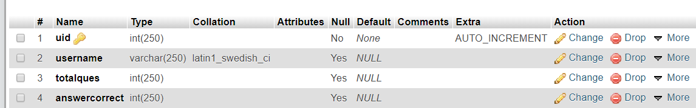user structure-

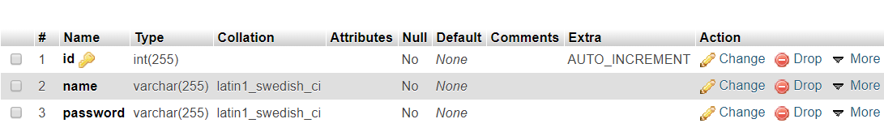signin structure-

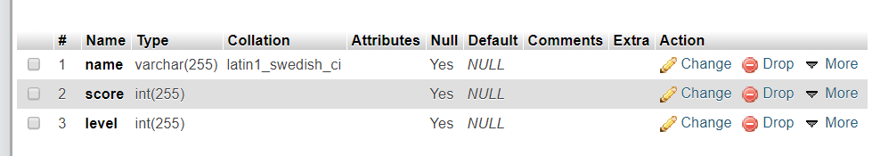tetristable structure-

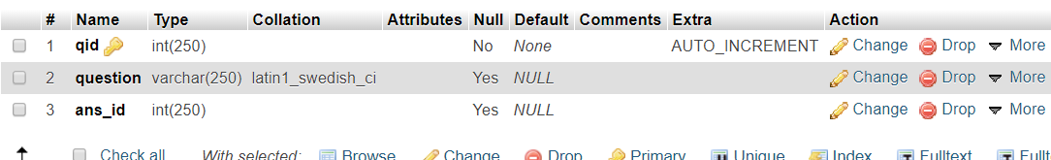question, question1, question2 structures-

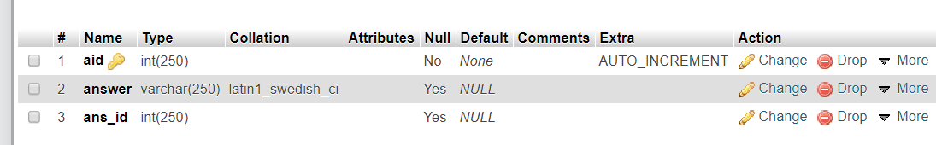answers, answers1, answers2 structure-

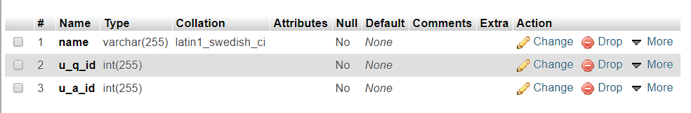usersessionss structure-

Flowchart

# Rules of a flowchart-

This shaped is used to start the flow or represent start of a flowchart.

In a flowchart this shape represents a

Process.

In a flow chart this shape represents a decision or a decision-making point.

In a flow chart this shape represents the end or termination point.

# Flow chart of current system-

List of Menu Items

* Create an account
* Log In
* Computer Science Quiz
* Mathematics Quiz
* Tetris-Mania
* Snake Infinity
* Dog Quiz
* Check Results
* Check Available Games Before Log In
* Logout

Logic Used for Calculations

# In Quizzes- (Mathematics, Computer Science etc.)

* Whenever the user correctly chooses an answer he will receive 10 point.
* The Quiz are of 5 questions therefore each answer carries 10 points that total is 50 points.
* So, if guess 2 questions correctly depending upon your score, you’re doing very poor.
* If you guess from 2 to 4 questions correctly, you’re doing satisfactorily.
* If you get all questions correctly you will receive a genius know it all comment.

# In Tetris-Mania –

Whenever you clear a line you receive 50 points.

* There are 5 types of Tetris blocks O, L, Z, I, T we have to mix and match to form a line. When you clear all four lines it’s called a Tetris and you get 200 points.

# In Snake Infinity-

* It’s a never-ending loop where basically your tail is the score.
* When you eat a food, your tail gets increased therefore your score becomes 1.
* Initially your tail lengths are 4 there we take your snake length subtract it by 4 to get a 0 score initially and then as your tails increases your score gets incremented by 1.

Results of Software Testing

Testing can be done based on test cases. Test case has components that describes an input, action or event and an expected response, to determine if a feature of an website is working correctly

For this project the application must generate the following,

* Valid username
* Valid password

The input given by the user must be checked from the database.

Login ID= {Valid login ID, Invalid login ID}

Password= {Valid password, Invalid password, Empty}

Steps formatting to carry out the test for Login Page-

* Valid Login page
* Enter Email ID
* Enter password
* Click Login

# Unit Testing-

In our system, Unit testing has been successfully handled. The test data was given to each and every module in all respects and got the desired output. Each module has been tested found working properly.

# Integration Testing-

Test data should be prepared carefully since the data only determines the efficiency and accuracy of the system. Artificial data are prepared solely for testing. Every program validates the input data.

# Validation Testing-

In this, all the Code Modules were tested individually one after the other. The following were tested in all the modules.

1. Loop testing
2. Boundary Value analysis.
3. Equivalence Partitioning Testing

In our case all the modules were combined and given the test data. The combined module works successfully without any side effect on other programs. Everything was found fine working.

# OUTPUT TESTING

This is the final step in testing. In this the entire system was tested as a whole with all forms, code, modules and class modules. This form of testing is popularly known as Black Box testing or system testing. Black Box testing methods focus on the functional requirement of the software. That is, Blackbox testing enables the software engineer to derive sets of input conditions that will fully exercise all functional requirements for a program. Black Box testing attempts to find errors in the following categories; incorrect or missing functions, interface errors, errors in data structures or external database access, performance errors and initialization errors and termination errors.

# Test Cases-

## User-

|  |  |  |  |  |
| --- | --- | --- | --- | --- |
| Module no | Name | Expected Behavior | Experimental Behavior | Status |
| 1 | Signup | This for the new users to give their details | New users can give inputs here, which are stored into database. | Passed |
| 2 | Login | This is verification page for users. Only a valid user can Login. | The inputs given by the users are checked from the database. | Passed |

# Cross Browser Testing-

Website was tested on multiple browsers such as Edge, Chrome, Firefox. The slight variation in display could be seen but the functionality of the project remains intact. No bugs or errors were found. The project passed the cross-browser tests as well.

Deployment

* In Deployment we need to first buy a domain.
* A domain should have a unique website identification title which starts with a www and ends with .com, .in, .net, .org.
* Once a name is confirmed a domain is bought and then we upload all the php, html, JavaScript files under a www folder.
* We will upload all the Database into the database portion.
* We will make the status of the website active.
* A final stage of the project is development once all the variable is set in place the website will be active all around the world for anyone to access.
* A standard domain costs around 1500 rs to 2000 rs a year to host for a controlled capacity of user activity.
* In deployment all the local connection should be routed into net connection ports.

User Manual

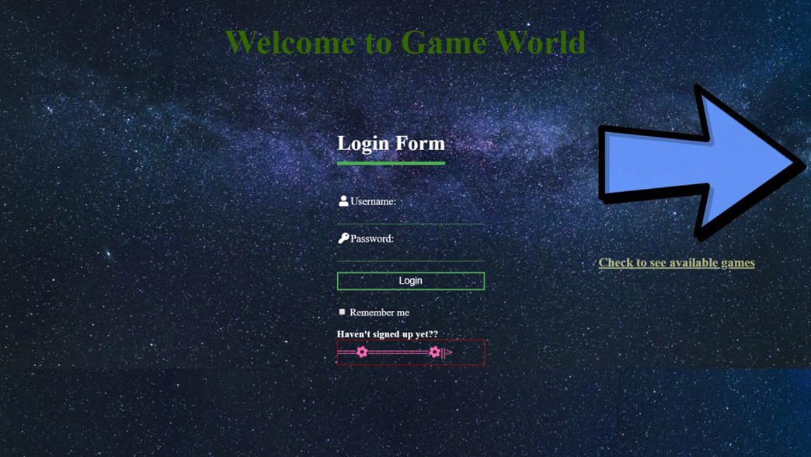

* + - 1. This the index page or the main page of the website.

1. To see available games, click on the arrow icon to check the available games without logging in.
2. Or
3. Click on the SignUp section the register if you’re a new user.

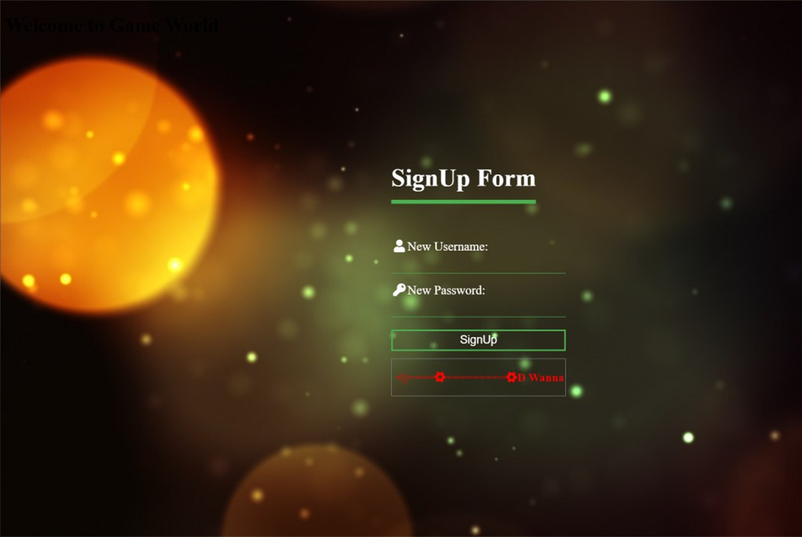

1. Enter your Username which can be anything From Characters to Integer or a combination of both.
2. After Clicking the SignUp button after clicking all the fields you will be taken back to the Login page.
3. Enter your authentication credentials correctly and continue to Home page.

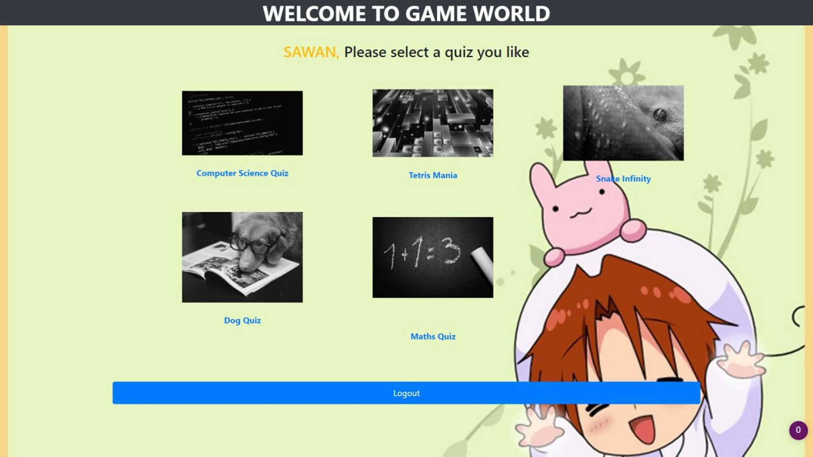

1. The home page you will see different games available for you to play.
2. The quiz games require for you to click on the check boxes to enter your answers.
3. The graphical games use the “Up arrow, Down Arrow ,Left arrow, Right arrow key “ to move around or interact with the game.
4. Click the Logout Buttons to Logout of your account.
5. Click the Back button to visit the previous page you visited.
6. Click the name of your game title or your Username heading to return to the Home page of your account.

